**LAB 1:**

**Creating EFS systems and assigning security groups:**

1. Navigate to AWS Management console and open the Elastic File System service.

Click on **File System**.

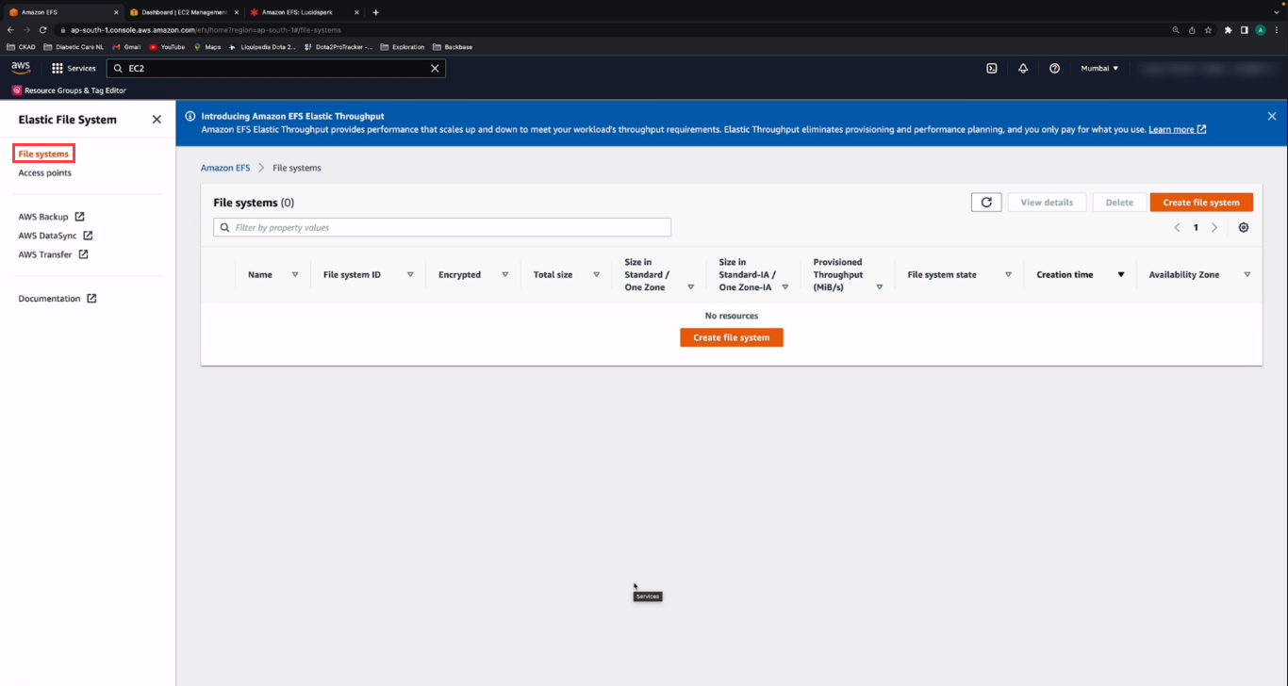

1. After that click on the **Create File System**.

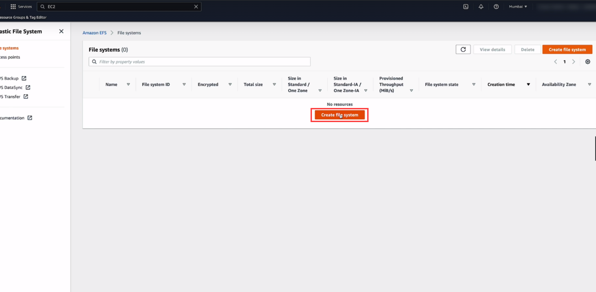

1. Enter the below configurations as show in the below screenshot:
2. Name: Name your File System.
3. Storage Class:

* Standard: Stores data redundantly across multiple AZ’s.
* One Zone: Stores data redundantly within single AZ.

Select the **Standard Storage class**.

1. Automatic Backup: Automatically backup your data with AWS Backup using recommended settings.

Select **Enable automatic backups**.

1. Lifecycle Management: Select

* Transition into IA: **30 days since last access**.
* Transition out of IA: **On first access**.

1. Encryption : **Enable encryption of data at rest**.

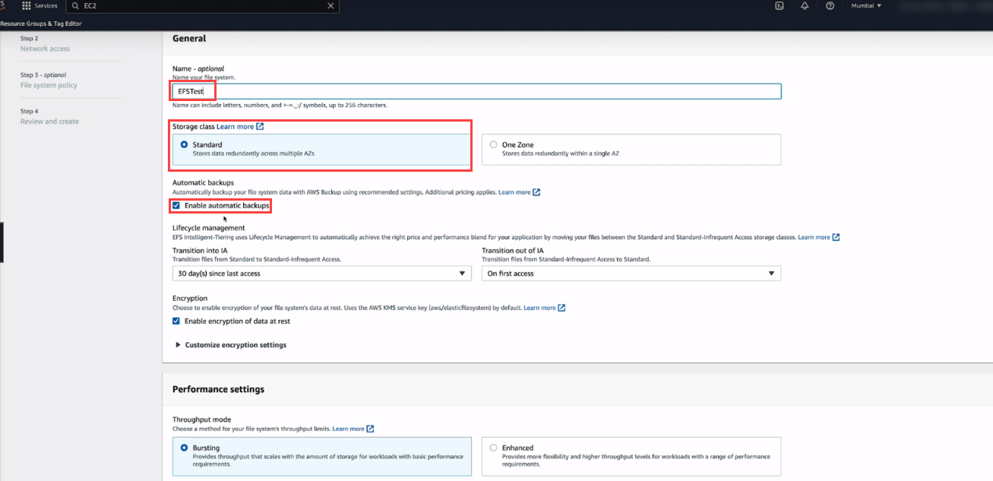

1. Performance Settings:

* Throughput Mode: **Bursting**

Provides throughput that scales with the amount of storage for workloads with basic

Performance requirements.

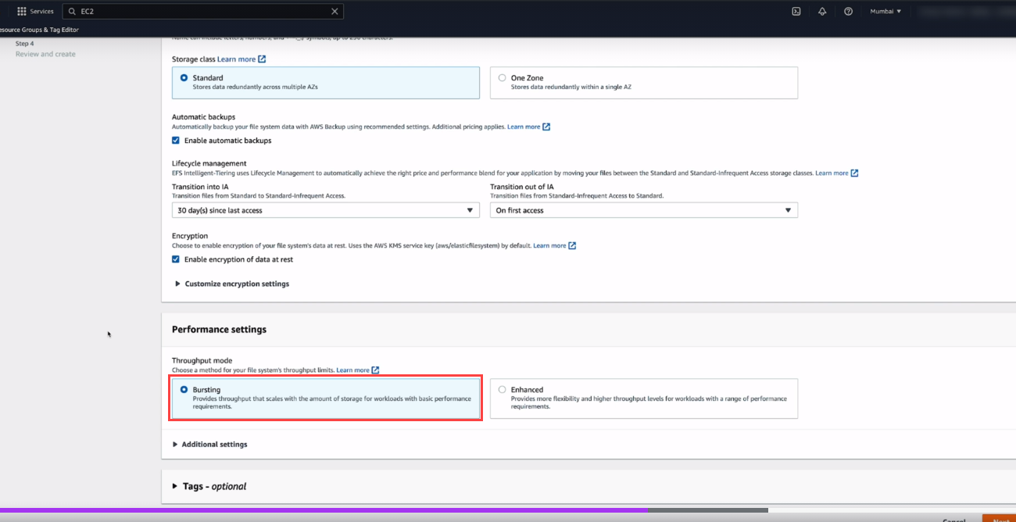

* Performance Mode: **General Purpose (recommended)**

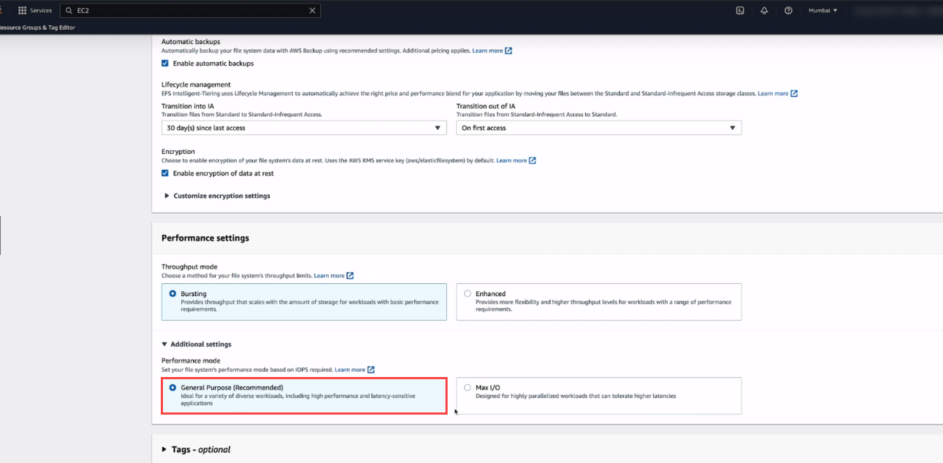

* Select Enhanced Throughput Mode

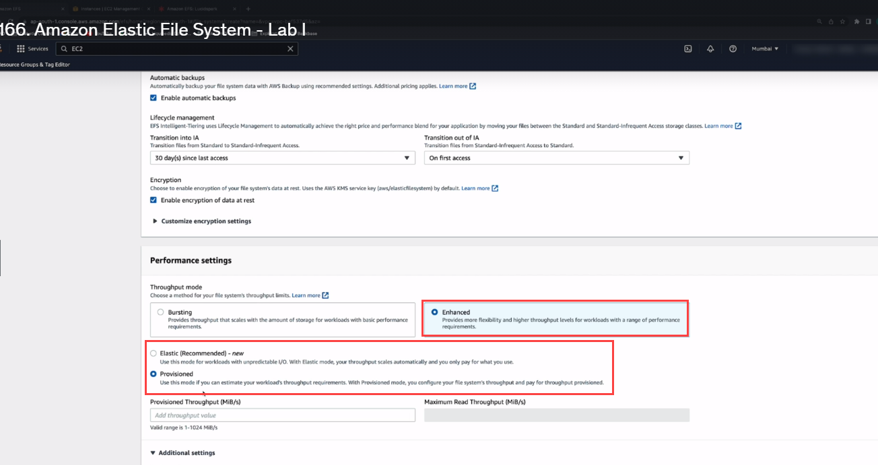

1. After File System settings configure the Network access configurations.

Choose the VPC where you want EC2 instances to connect to your file system.

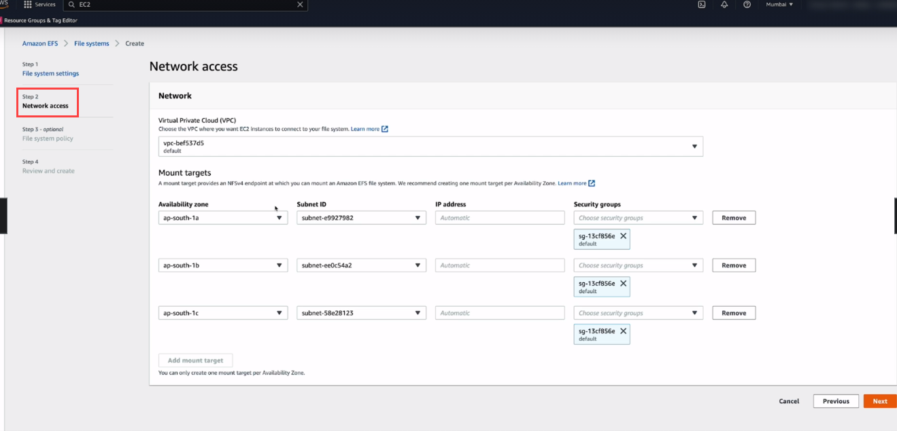

1. Create the Mount target in each availability Zone for mounting the File system.

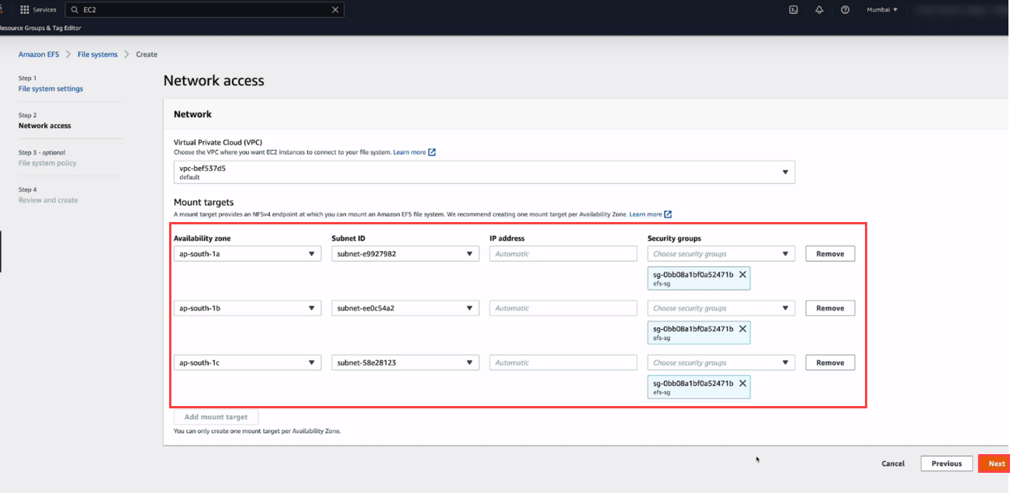

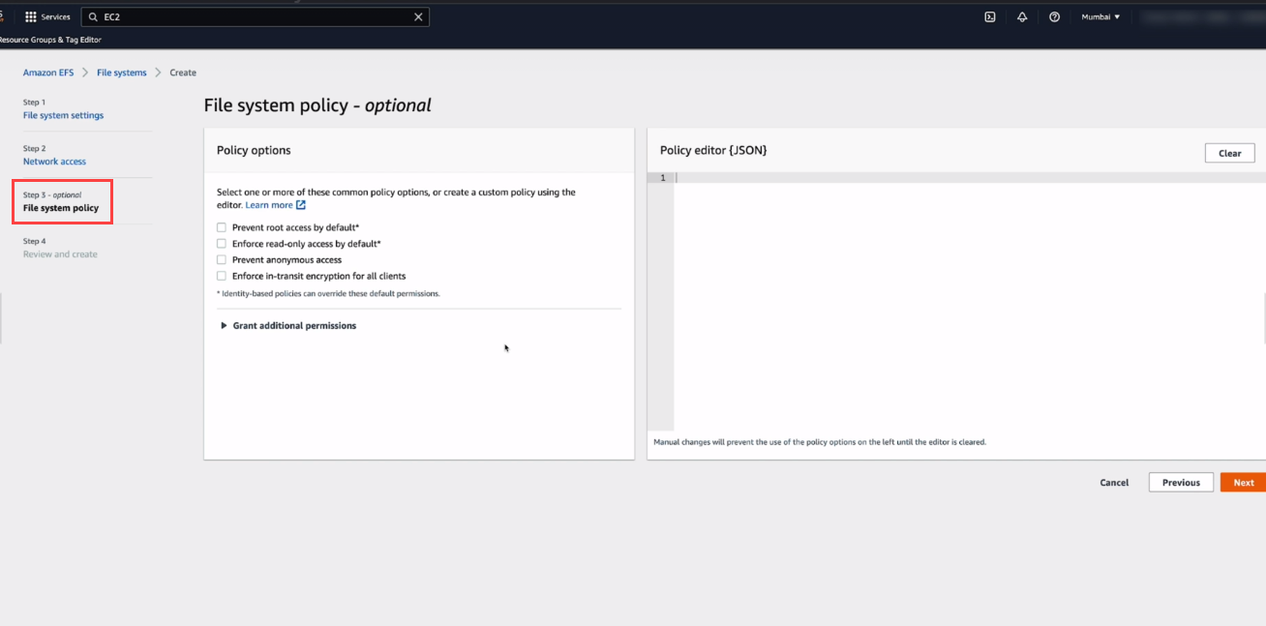

1. Create the File system Policy

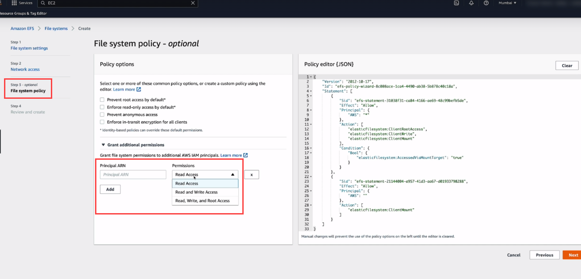

1. Review the File System configurations and create the File System.

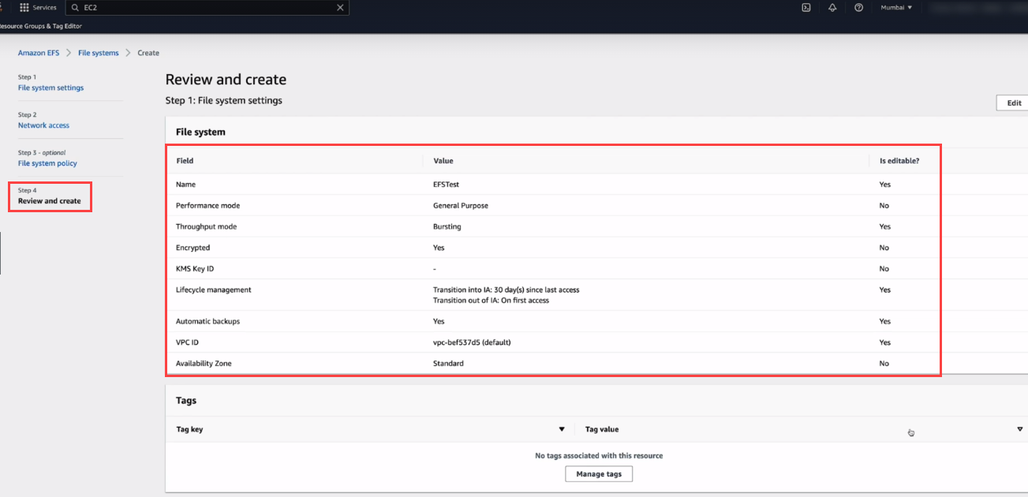

1. Then on the EFS dashboard you are able to see the Filesystem is created.

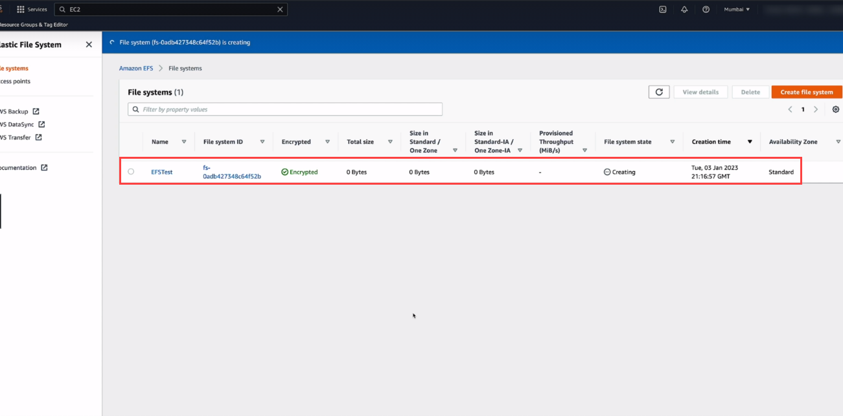

1. Check the General information of File system.

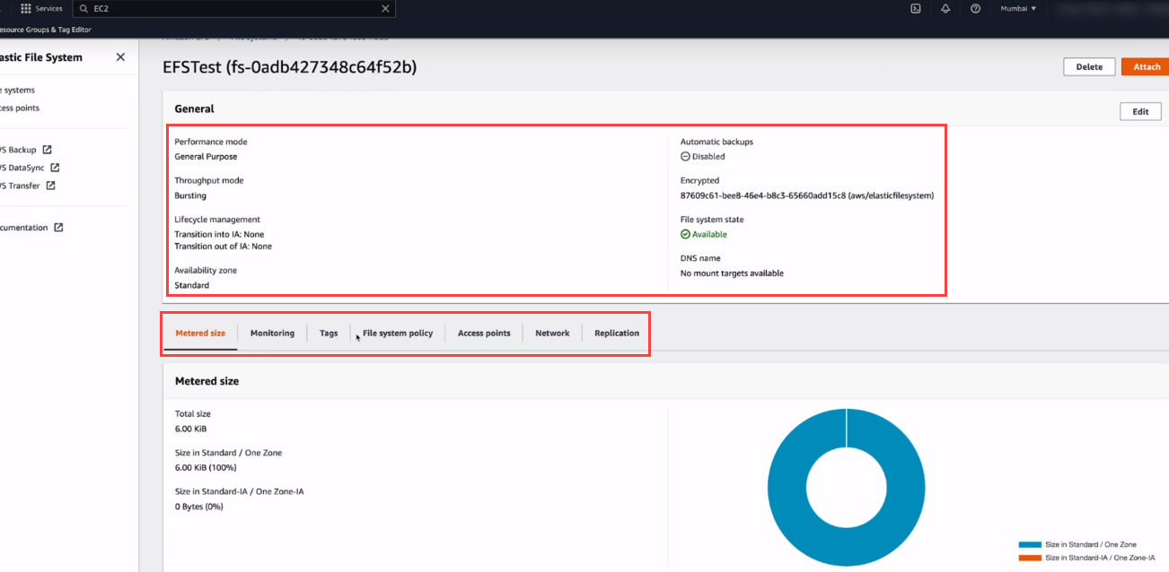

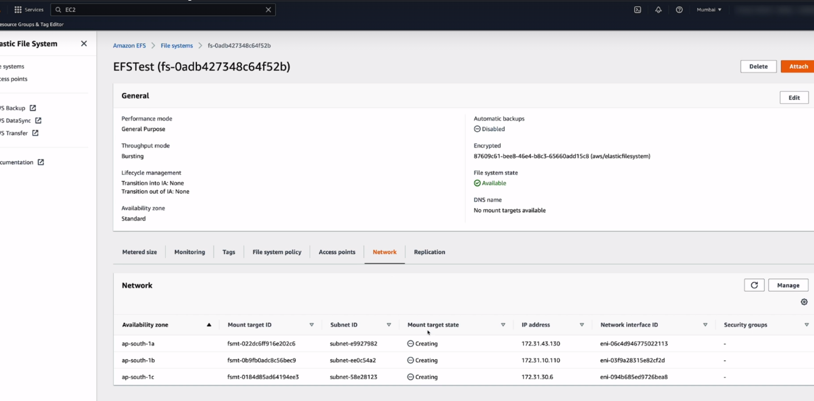

LAB 2:

Mounting the EFS storage on the EC2 instance.

For mounting the EFS storage on EC2 follow the below procedure:

1. SSH into the EC2 instance using below command:

**ssh ec2-user@43.205.213.116 -i akshaypk-mumbai.pem**

switch to root user.

1. Update all the packages using the below command

**yum update -y**

1. Install the Amazon EFS utils using the below command:

**Yum install -y amazon-efs-utils**

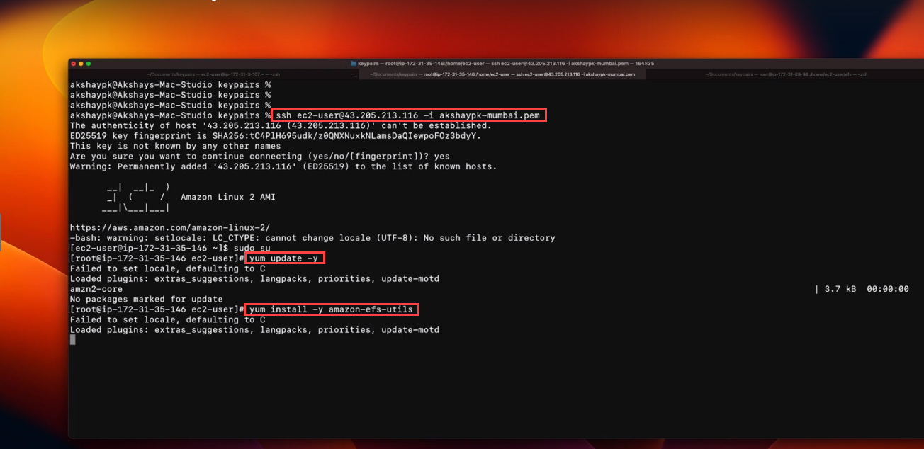

The Amazon EFS client (amazon-efs-utils) is an open-source collection of Amazon EFS tools. It includes a mount helper, tooling that makes it easier to perform encryption of data in transit for Amazon EFS file systems, and other utilities.

The amazon-efs-utils package is available in the Amazon Linux package repositories, and you can build and install the package on other Linux distributions. You can also use AWS Systems Manager to automatically install or update the package.

The Amazon EFS client includes the following tools:

* mount.efs: A mount helper that makes it easier to mount Amazon EFS file systems.
* efs-util.py: A Python utility that you can use to perform various tasks on Amazon EFS file systems, such as creating, listing, and deleting file systems.
* efs-provisioner: A tool that you can use to provision Amazon EFS file systems from a template.
* efs-mount-watchdog: A watchdog process that monitors the health of TLS mounts.

1. Then you are able to see the installing status and version of the utils package.

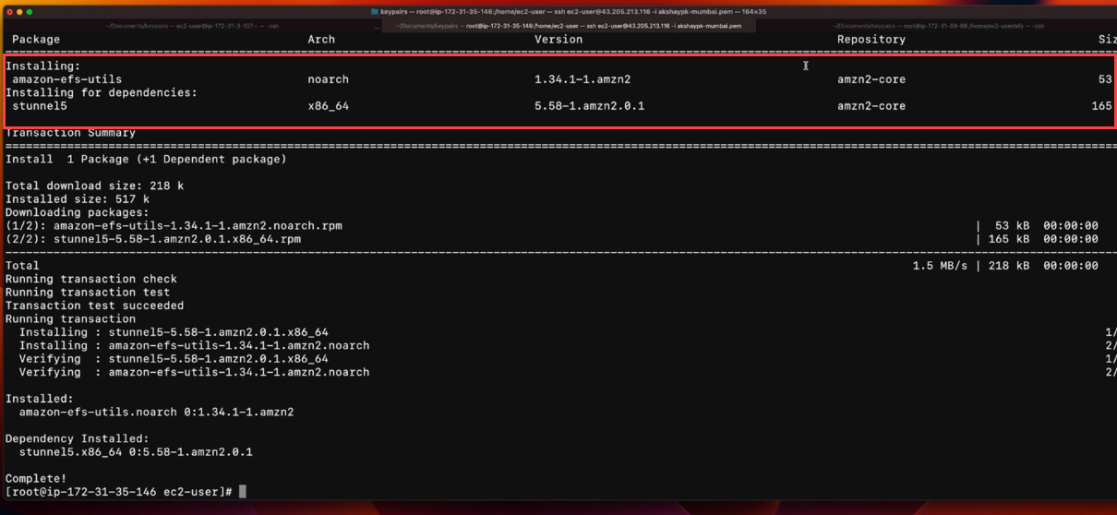

1. After installing the amazon-efs-utils package click on the **Attach button** as shown in the below screenshot.

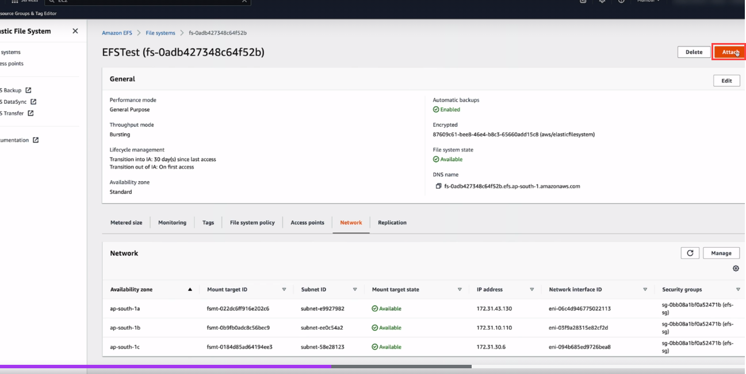

1. Copy the command for mounting the EFS file system using the EFS mount helper. Use the below command for mounting the EFS file system:

**sudo mount -t efs -o tls <EFS file system name>:/ efs**

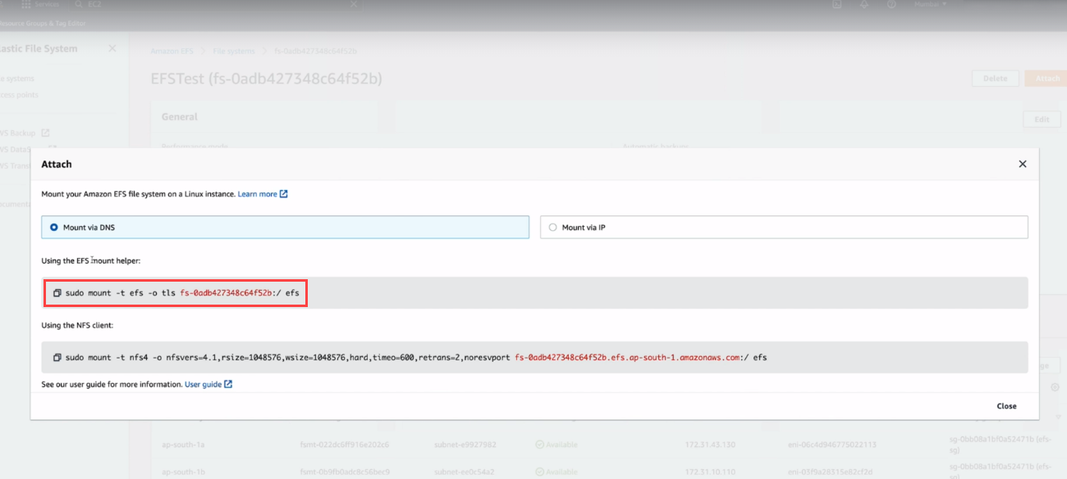

1. Enter the command in the command prompt and press enter.

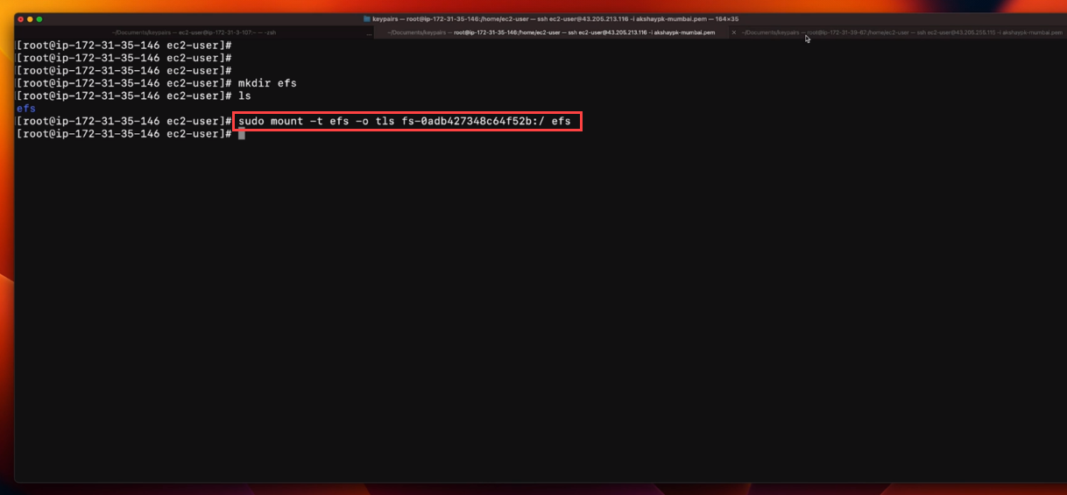

1. If efs directory is not present then use the below command to create the directory:

**mkdir efs**

* Then again run the command for mounting as shown in the below screenshot.
* Check the memory information using the below command to see the efs file is mounted or not as shown in the below screenshot. Use the below command:

**df -h**

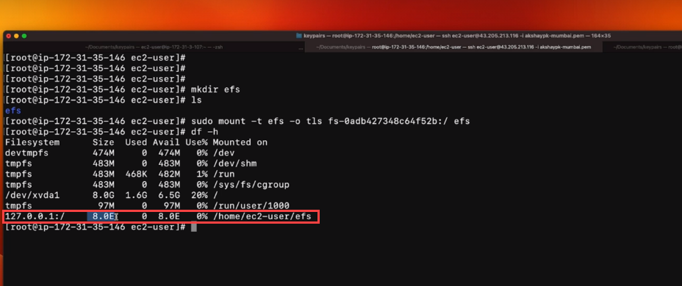

1. Go to the efs directory using the below command:

**cd efs**

Host the index.html file and check that it will show the hosted file.

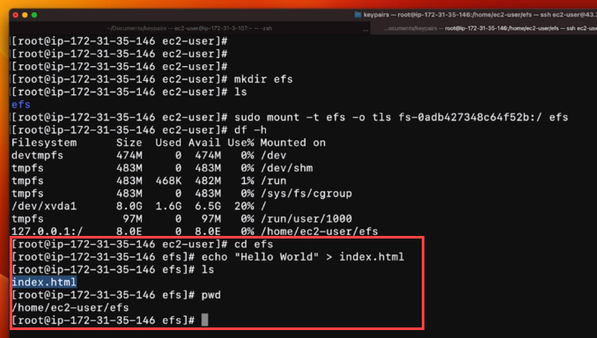

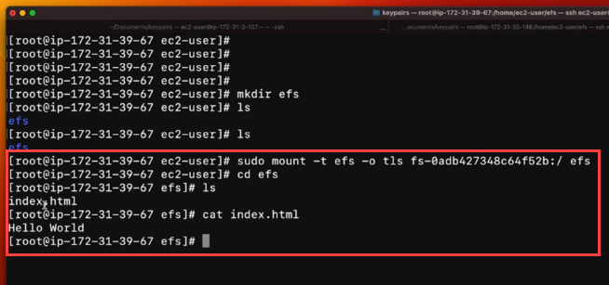

1. For deleting the File system click on the **Delete button** as shown in the below screenshot.

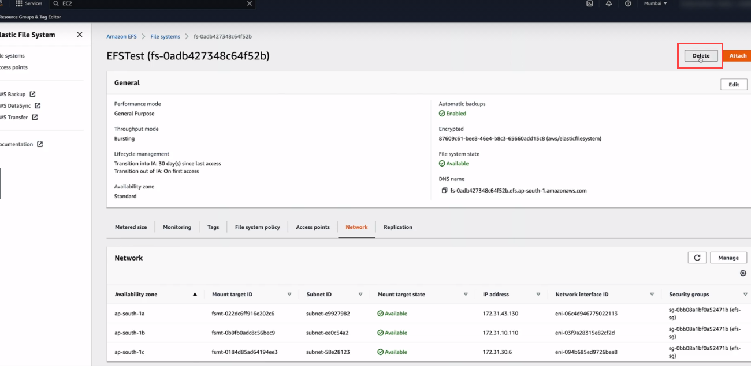

1. Then for confirmation of the deletion enter the file system name as shown in the below screenshot and click on the **confirm** button.

